ABC Payroll Program User Documentation
SDEV268, Winter 2025
Group 3

Table of Contents

Introduction - pg. 3
Website Overview - pg. 4
Input Requirements - pg. 6
Data Validation Rules - pg. 7
Payroll Calculation Process - pg. 8
Screen Layout and Navigation - pg. 10
Troubleshooting - pg. 20
Best Practices - pg. 21
Support - pg. 22

Introduction

ABC Payroll Program is designed to streamline payroll management by automating the collection of employee work hours, applying deductions and taxes, and generating accurate payroll results. This system provides organizations with a secure, user‑friendly tool that reduces manual effort, minimizes errors, and ensures compliance with payroll rules and regulations.
This documentation serves as a comprehensive guide for both administrators and employees. It explains how to access the program, what information is required at each step, and how the system validates and processes data. In addition to technical instructions, the guide includes hypothetical examples that illustrate typical user scenarios — such as an employee entering weekly hours, an administrator approving PTO requests, or HR staff generating payroll reports. These examples are designed to help users understand not only what the system does, but how they should interact with it in real‑world situations.
The document is organized into clear sections that mirror the workflow of the program:
- Website Overview – How to log in, navigate menus, and understand role‑based access.
- Input Requirements – What data employees and administrators must provide, such as hours worked, dependents, or medical coverage.
- Data Validation Rules – How the system checks for accuracy, including safeguards against invalid entries or excessive hours.
- Payroll Calculation Process – Step‑by‑step explanation of how gross pay, deductions, and net pay are computed.
- Screen Layout and Navigation – Visual and descriptive guidance for moving through the program’s screens.
- Database and Information Management – How employee records, time entries, and payroll data are stored and accessed securely.
- Troubleshooting – Common issues users may encounter and how to resolve them.
- Best Practices – Recommendations for efficient and secure use of the system.
- Support – Where to go for help, including technical assistance and documentation resources.

Website Overview
The Payroll Program is delivered through a secure, web‑based interface that guides users step‑by‑step through the payroll process. The design emphasizes clarity, efficiency, and role‑based access, ensuring that administrators and employees can easily complete their tasks while maintaining data integrity and security.
The system is organized into structured workflows that align with the payroll cycle. Each workflow is presented through intuitive screens and menus, allowing users to move seamlessly from data entry to payroll calculation and reporting.

Major Components
- Collecting Hours Worked Employees enter their daily or weekly hours through a dedicated time entry screen. The interface supports regular hours, overtime, and PTO requests. Once submitted, entries are locked after payroll is processed to prevent retroactive changes. Administrators can review and modify these entries, ensuring accuracy before calculations begin.
- Capturing Employee Information Administrators manage employee records through the Employee Management screen. This includes adding new employees, editing existing details (such as job title, department, or medical coverage), and removing terminated employees. Each record is linked to the database and validated for completeness (e.g., age ≥ 18, valid email format).
- Calculating Taxes and Deductions The Payroll Calculation screen applies standardized formulas to compute gross pay, pre‑tax deductions (medical coverage, dependent stipends), and statutory taxes (state, federal, Social Security, Medicare). The system automatically distinguishes between salaried and hourly employees, applies overtime rules, and generates net pay results.
- Validating Input Data Built‑in validation rules ensure that all required fields are completed and that entries fall within acceptable ranges. Examples include flagging excessive hours, preventing duplicate employee IDs, and enforcing secure password requirements. Validation occurs in real time, reducing errors and ensuring compliance before payroll is finalized.

Navigation and User Roles
- Employee Role: Employees access streamlined screens for time entry, PTO requests, and paycheck viewing. Navigation is simplified to reduce confusion and ensure quick completion of tasks; with dependencies on if the employee is salaried or hourly.
- Administrator Role: Admins have access to advanced tools for managing employee records, editing timecards, running payroll calculations, and generating reports. Menus are organized to separate administrative functions from employee‑level tasks.

Design Principles
- Clarity: Each screen uses consistent layouts, labels, and prompts to guide users.
- Efficiency: Common tasks (e.g., entering hours, generating payroll) are optimized to require minimal clicks.
- Security: Role‑based access ensures that sensitive payroll data is only available to authorized users.
- Traceability: All actions are logged, providing administrators with a clear audit trail of changes and submissions.

Input Requirements

Hours Worked
The Hours Worked section allows employees to record the total number of hours they worked during each pay period. This input is critical for accurate payroll calculation, especially for hourly employees.
- Standard Expectation: The system assumes a standard 40‑hour work week for most employees.
- Overtime Handling: Any hours beyond 40 in a week, or more than 8 hours in a single day, are automatically flagged as overtime. Saturday hours are also treated as overtime and calculated at time‑and‑a‑half.
- PTO Integration: Employees may enter PTO hours separately, which are validated against their available balance.
- Validation Rules:
  - Entries exceeding 80 hours in a pay period trigger a warning.
  - Negative or blank entries are not accepted.
  - Once payroll is processed, time entries are locked to prevent retroactive changes.
Administrators can review, approve, or adjust submitted hours before payroll is finalized. This ensures that all reported time is accurate and compliant with company policy.

Data Validation Rules

Automatic Inconsistency Detection
The program continuously monitors user inputs and stored records to ensure logical consistency across all modules. When discrepancies are detected, the system flags them immediately and provides contextual guidance for correction. Examples of automatic checks include:
- Cross-field validation: Ensures that related fields (e.g., start date vs. end date) follow logical order.
- Duplicate detection: Identifies repeated entries such as employee IDs, invoice numbers, or usernames.
- Range enforcement: Validates that numeric values (e.g., hours worked, salary rates) fall within acceptable thresholds.
- Dependency checks: Confirms that prerequisite data (e.g., department assignment before payroll calculation) is present before dependent operations run.
- Format verification: Detects invalid formats in structured fields such as email addresses, phone numbers, or date strings.
When an inconsistency is found, the system highlights the affected field(s) and provides a descriptive error message. In most cases, corrections can be made directly without leaving the current workflow.

Required Fields
Certain fields must be completed before records can be saved or processed. These required fields ensure that critical data is always captured and prevent incomplete submissions. Key rules include:
- Mandatory identifiers: Employee ID, first name, last name, gender, address
- Core attributes: Names, dates, and classification fields (e.g., job role, department) are required for accurate reporting.
- Transaction essentials: For payroll or billing, hours worked, pay rate, and applicable deductions must be provided.
- Contact information: At least one valid communication channel (email or phone) is required for each profile.
- System-critical flags: Boolean or dropdown selections (e.g., active/inactive status) must be set to avoid ambiguity.

Payroll Calculation Process
Once all employee data is entered and validated, the ABC Company Payroll Project automatically executes a secure, step-by-step payroll calculation. This ensures accuracy, compliance with tax rules, and consistency across both salaried and hourly pay structures.

Gross Pay Calculations
- Hourly Employees:
  - Standard pay = hours worked × hourly rate
  - Overtime pay = hours beyond 40 × 1.5 × hourly rate
- Salaried Employees:
  - Fixed gross pay based on annual salary divided by pay periods.
- Adjustments:
  - PTO requests, unpaid leave, and special allowances are factored into gross pay before deductions.

Pre-Tax Calculations
Before taxes are applied, the system subtracts mandatory and optional deductions:
- Medical Coverage:
  - $50 for single coverage
  - $100 for family coverage
- Dependent Stipends:
  - $45 per dependent, automatically calculated based on employee records
- Other Deductions:
  - Configurable fields for retirement contributions, insurance premiums, or other employer-defined benefits.

Tax Calculations
The system applies federal, state, and local tax rules to the adjusted gross pay. Both employee and employer contributions are calculated simultaneously for compliance and reporting.

Tax Type | Employee Rate | Employer Rate
State Tax | 3.15% | 3.15%
Federal Tax | 7.65% | 7.65%
Social Security | 6.2% | 6.2%
Medicare | 1.45% | 1.45%
- Employee Withholding: Deducted directly from gross pay.
- Employer Contribution: Recorded separately for reporting and compliance.
- Validation: The system ensures tax rates are applied consistently across all employees.

Net Pay Generation
After deductions and taxes, the system produces the net pay — the final amount the employee receives.
- Paycheck Details: Employees can view a breakdown of gross pay, deductions, taxes, and net pay through their role-based dashboard.

Screen Layout and Navigation

Login Page
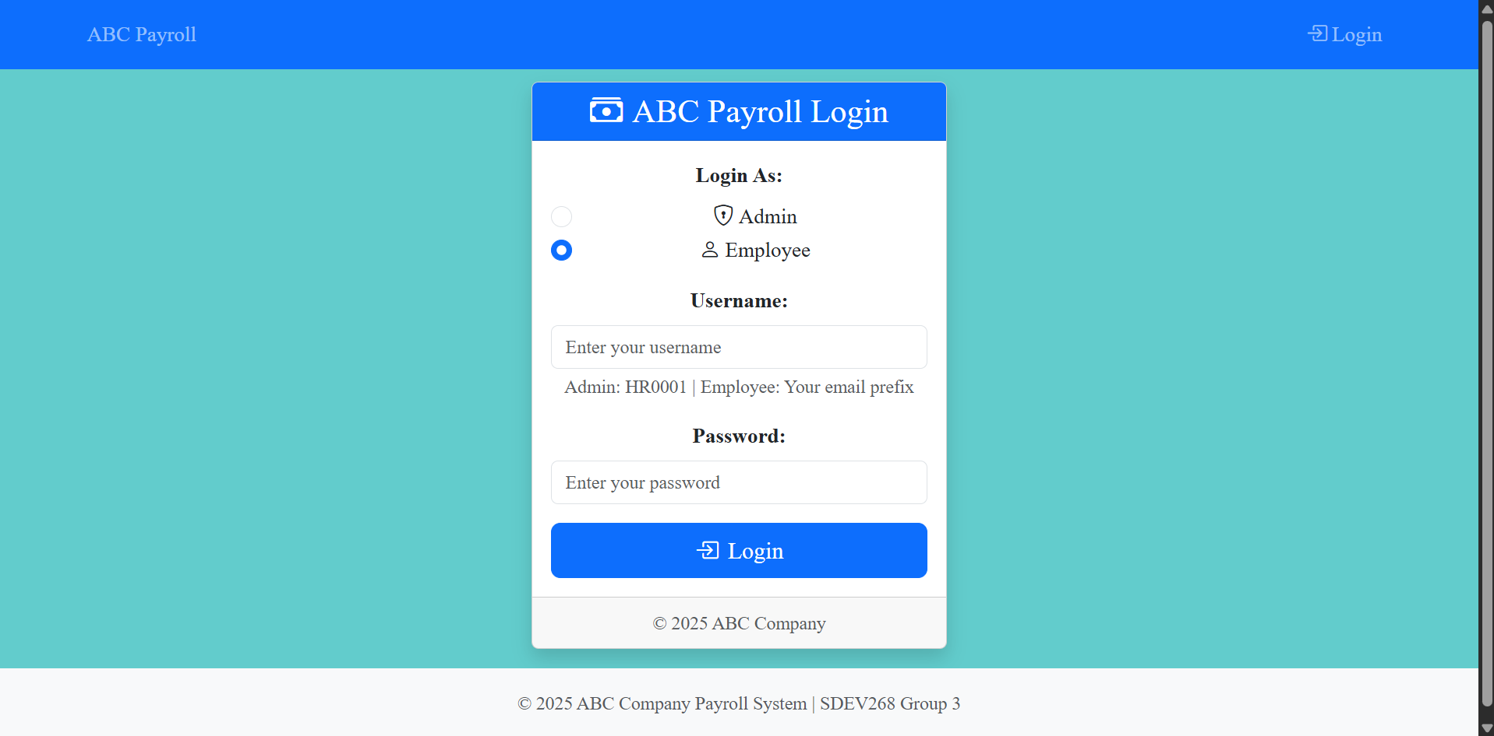
From here, the user can select their correct role and then enter in their credentials. If there is an error in any of the fields, an error message will be displayed.

Admin Portal
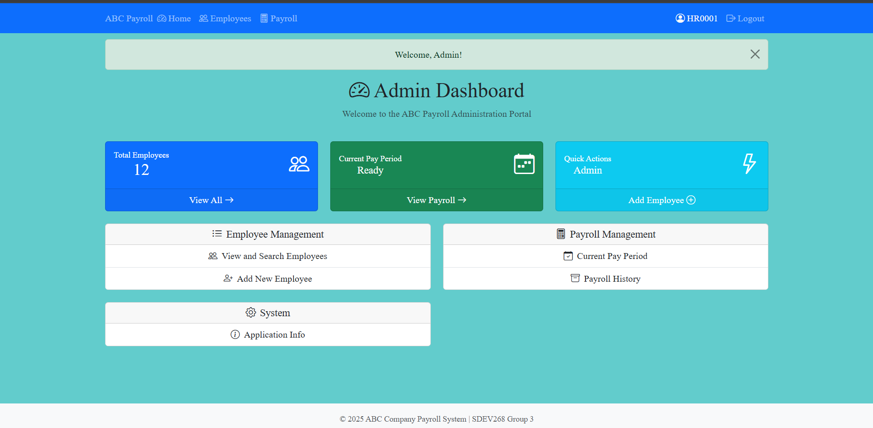
Provides full access to employee and payroll management functions:
- Employee Management: View and modify personal and pay details.
- Employee Creation: Add new employee records with required fields.
- Payroll Authorization: Approve and finalize payroll runs.
- Timecard Modification: Adjust submitted timecards when corrections are needed.
- Application Info: Access system details and administrative settings.
- Record Management: View, update, or delete employee records.
- Payroll Oversight: Review flagged inconsistencies and manage payroll compliance.

Employee Portal
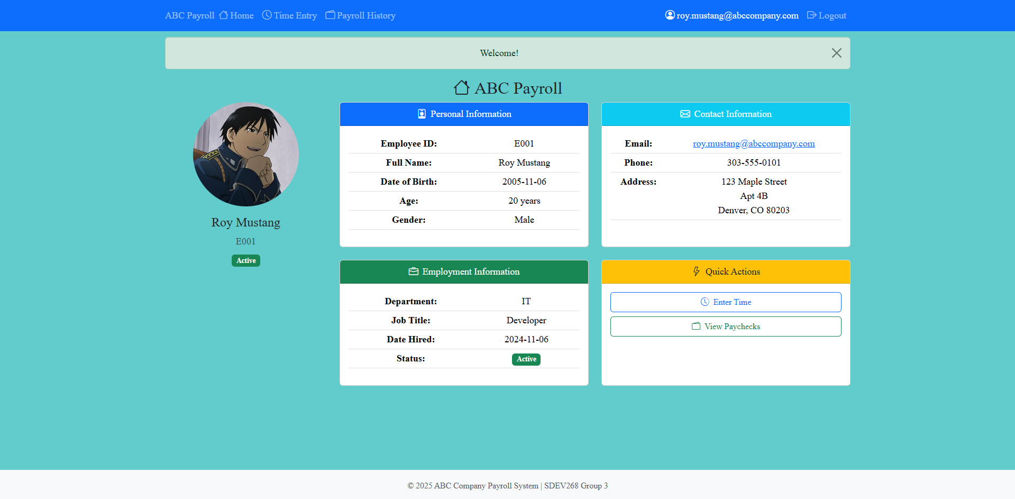

Designed for both salaried and hourly employees:
- Timecard Entry – Salary: Enter PTO hours only. A projected paycheck for the current pay period is displayed alongside the entry terminal.
- Timecard Entry – Hourly: Enter regular worked hours and PTO hours. A projected paycheck is displayed for the current pay period.
- Paycheck History: Review past timecards with detailed breakdowns of gross pay, net pay, deductions, and taxes.

Admin Employee Management (Pay and Personal Detail View/Modification)
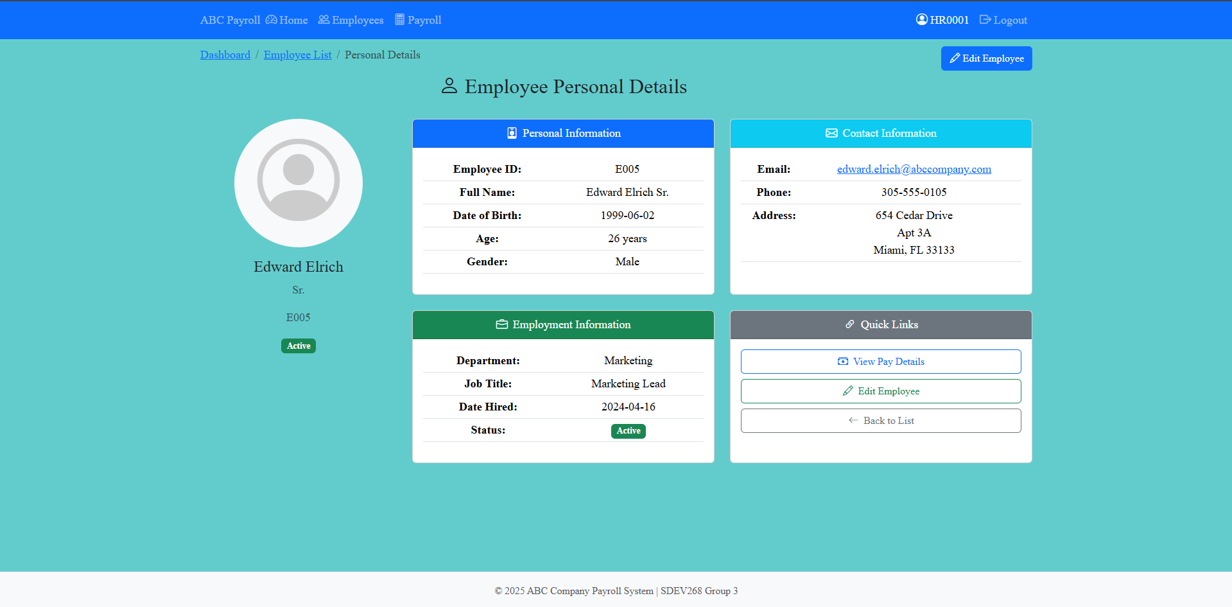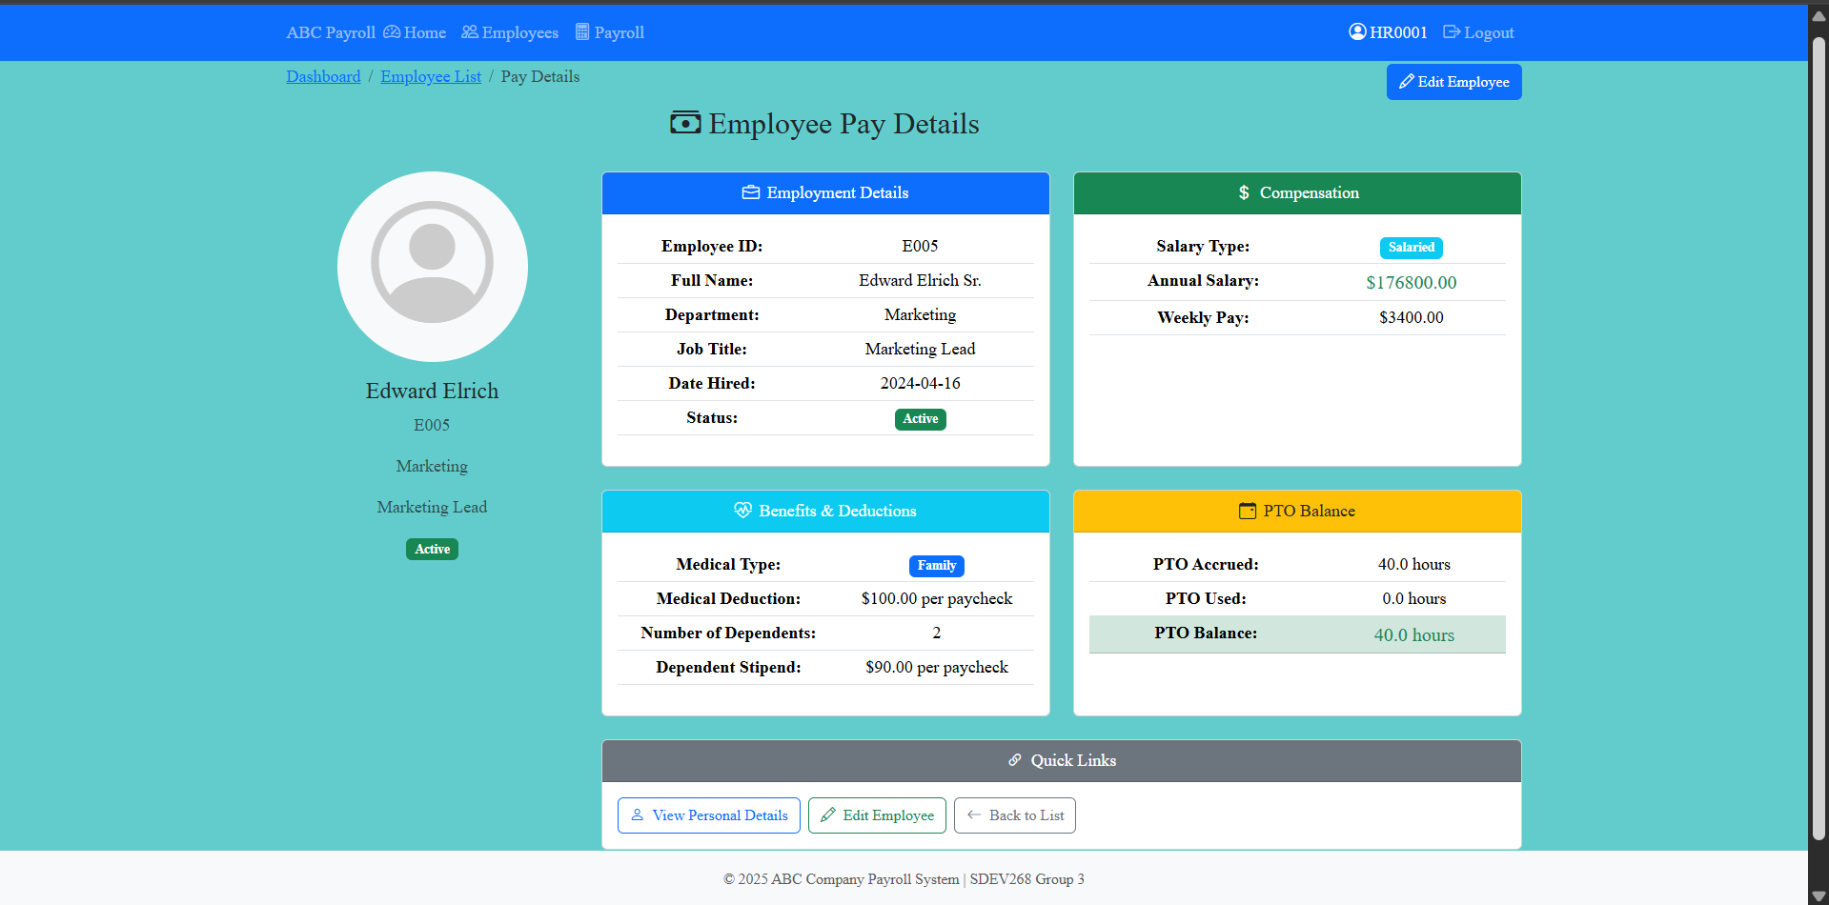
These pages provide administrators with direct access to employee information, ensuring that records remain accurate and up to date. Both personal details and pay details are displayed in a structured format, with options to modify fields as needed.

Personal Details
- Displayed Information: Name, contact information, address, role/department, and employment status.
- Editable Fields: Admins can update personal data such as phone numbers, email addresses, or department assignments.
- Validation: All changes are checked against required formats (e.g., valid email, phone number) before saving.

Pay Details
- Displayed Information: Pay type (hourly or salary), pay rate, overtime eligibility, benefit selections, and deduction settings.
- Editable Fields: Admins can adjust pay rates, update benefit coverage (single/family), and modify dependent counts.
- Payroll Integration: Any changes made here automatically update payroll calculations for the next cycle.

Admin Employee Creation
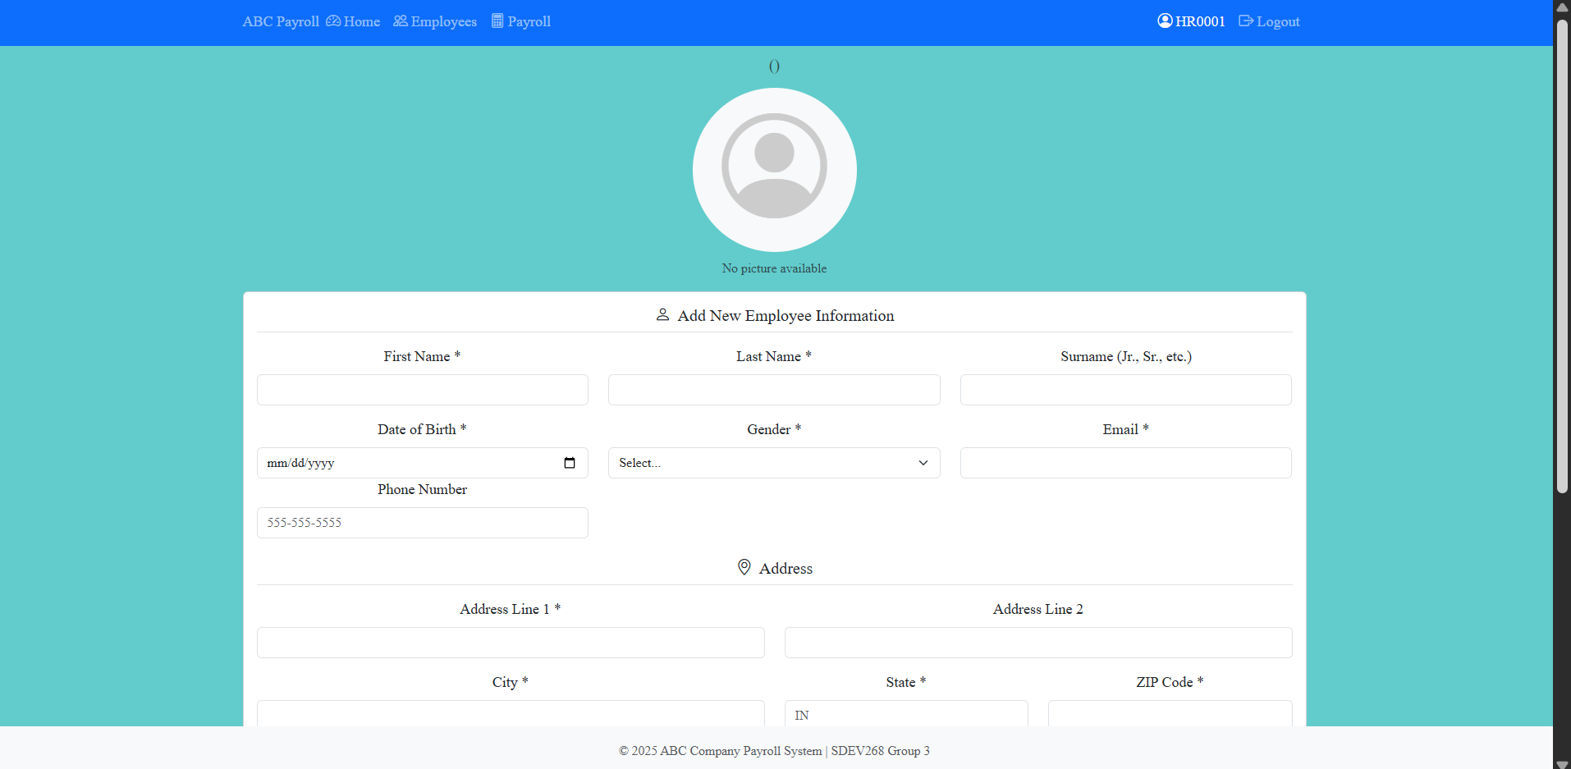
The Employee Creation page allows administrators to add new employees into the system with complete and validated records. This process ensures that payroll calculations, reporting, and employee access are all based on accurate and secure data.

Admin Payroll Authorization
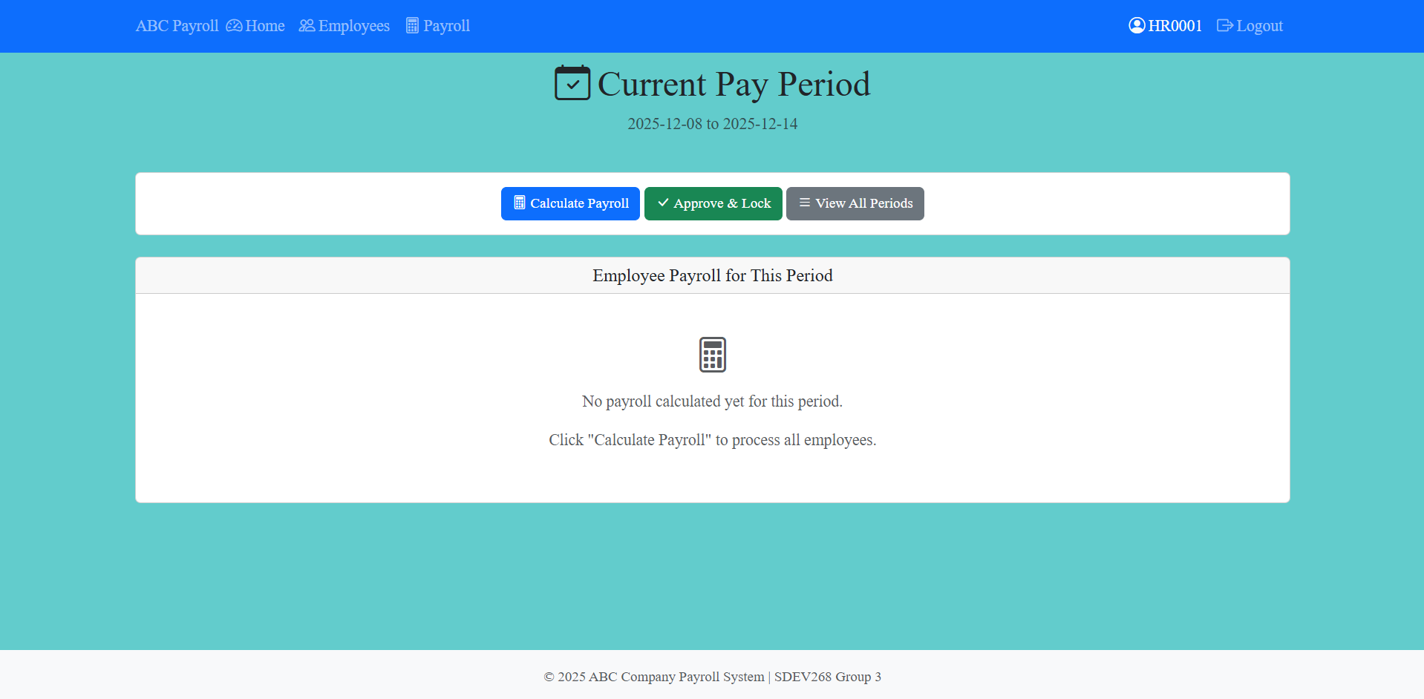
The Payroll Authorization page is the control center for administrators to review, approve, and finalize payroll runs. This ensures that all employee payments are calculated accurately and securely before distribution.
Review Pending Payroll
- Displays a summary of all employees scheduled for the current pay cycle.
- Includes gross pay, deductions, taxes, and projected net pay.
- Flags inconsistencies or missing data for correction before approval.
Review Past Payroll
- Access to individualized summaries of employees and their income breakdown for specified payroll periods
Calculate Payroll
- Allows for payroll to be exported and generated in full

Admin Timecard Modification

Admin Application Info
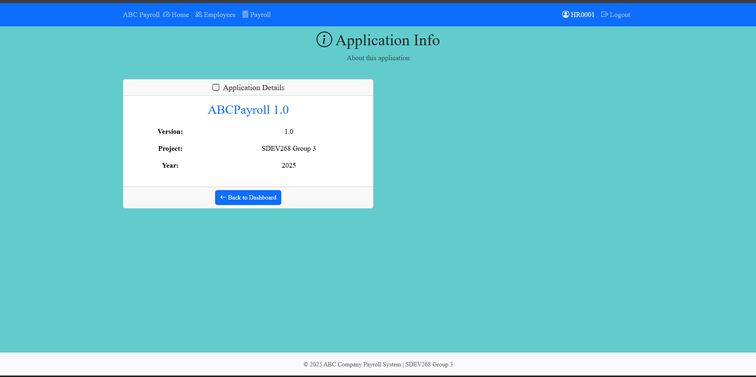

Employee Timecard Entry - Salary
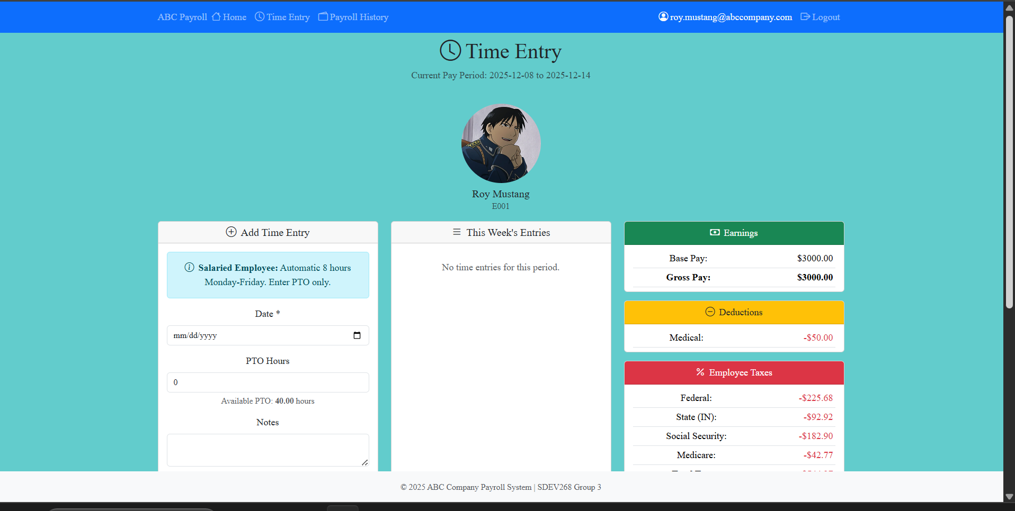

Employee Timecard Entry - Hourly
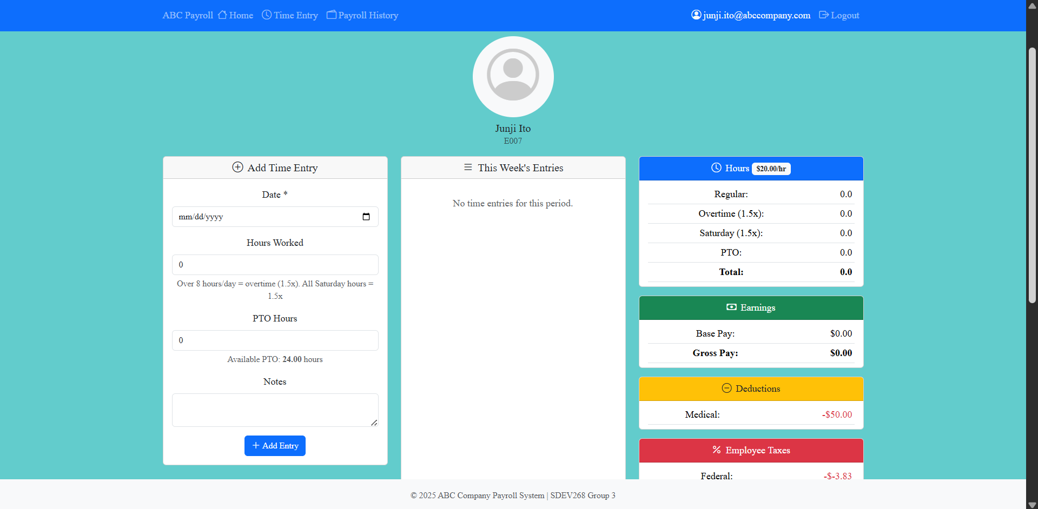

Employee Paycheck History
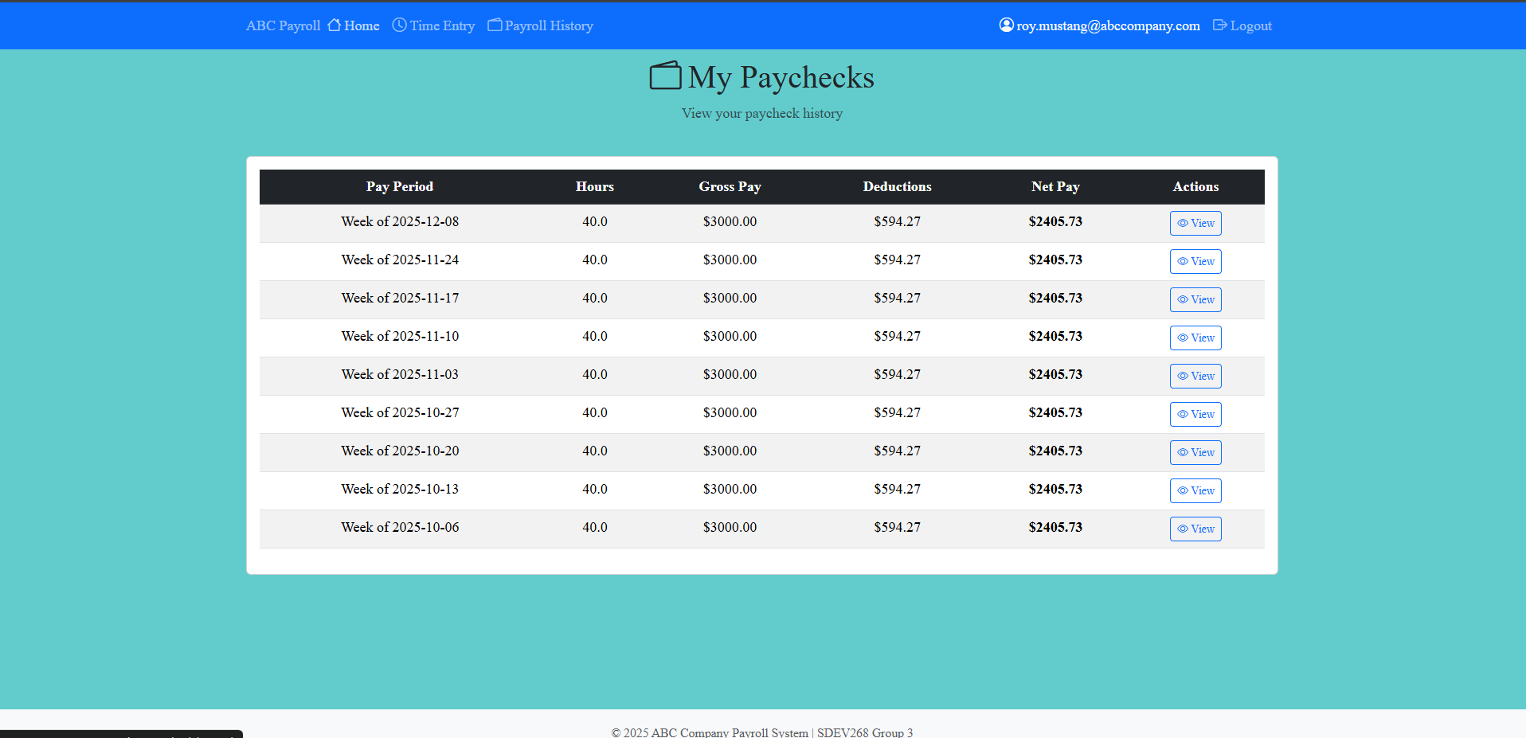
The Paycheck History page provides employees—both salaried and hourly—with secure access to their past payroll records. This feature ensures transparency, accuracy, and easy reference for financial planning or compliance purposes.

Data Entry Screens
All forms are designed for clarity and validation:
- Labeled Input Fields: Each field is clearly identified.
- Validation Messages: Immediate feedback highlights errors or missing required data.
- Instructions for Acceptable Values: Inline guidance ensures correct formatting and valid entries.

Navigation Summary
- Admins: Manage employee records, authorize payroll, and oversee system integrity.
- Employees: Enter hours, request PTO, and access paycheck details.
- Both Roles: Benefit from secure login, clear navigation, and consistent validation across all screens.

Database and Information Management

All data entered into the system is securely stored within the program’s centralized database. The design is structured to ensure reliability, compliance, and efficient access across all payroll operations. Key components include:
- Employee Records Comprehensive profiles containing personal details, role assignments, pay structures, and benefit selections.
- Payroll History A complete ledger of past payroll runs, including gross pay, deductions, taxes, and net pay for each cycle.
- Hour Logs Detailed time-tracking entries for hourly employees, overtime calculations, and PTO adjustments.
- Tax Reference Tables Predefined tax rates and contribution rules for federal, state, Social Security, and Medicare, ensuring consistent application across all employees.

Troubleshooting

Issue | Resolution
Hours flagged as unusual | Confirm they are correct or adjust to the expected range
Missing required fields | Fill in flagged fields before continuing
Data does not save | Check your internet connection and try again
Incorrect tax results | Review employee tax status and deduction settings

Best Practices

To maintain accurate payroll data:
- Review hours before submission
- Double-check unusually high or low values
- Ensure employee information is up to date
- Address inconsistencies immediately
- Verify final payroll results before approval

Support

For additional assistance, contact your payroll administrator or system support team.

